Frodo Shaya
September 19, 2018
Prof. Greg Shaya
History 208: Europe in the Era of Total War

A Title That Clearly Defines the Topic and Argument:
An Evocative Subtitle (Yes! Even for a Short Writing Assignment)

The purpose of this sample paper is simply to demonstrate the format of a paper for History 208. This is a format typically used for papers in history, a version of Chicago-style format with footnotes. Use one-inch margins and an easy to read 12-point font. Include your name, date, and class information in the upper left-hand corner. Include a title, centered above the text, without bold or italics or question marks (unless you are indeed quoting someone). The best titles will grab your reader’s attention and convey the main point of the paper. Cite all of your sources in footnotes.
The text should be double-spaced and left justified, with the first line of paragraphs indented. If you include a quotation of five lines or longer, you should “block indent” the quotation: indent one half inch on the left and right margins. Some ask for single space, some for double space. I will accept either. Here is an example:
Look here. This is what a block-indented quotation looks like. It’s at least four lines. Look here. This is what a block-indented quotation looks like. It’s at least four lines. Look here. This is what a block-indented quotation looks like. It’s at least four lines.
If you want to indicate that the lines that follow the block-indented quotation are part of the same paragraph, you should not indent the text after the quotation.

Heading
A word on section headings. These can be helpful in a long paper to give readers a clear sense of the organization of your paper. So, you might provide a section heading for the background section or the historiography or the primary source analysis.
Some general remarks on notes and citations. When should you use a citation? Most students use far too few citations. You should use citations: to identify the source of direct quotations, to identify the source of important ideas, to show how you know what you know, to point to other books or articles that are relevant, to give essential background that does not belong in the text, or to develop interesting tangents that do not belong in the text. A well researched paper will typically include one or two citations per paragraph. As you can see, citations can do a lot of different kinds of work, but the most essential is this: they take your reader directly to the sources—that is, the the very page—you are discussing.
There are a handful of different citation forms. Typically, they vary by discipline. For initial assignments, I often allow students to use informal methods of citation, such as parenthetical references to author and page number. But as historians you would like to learn to appropriately use footnotes, following the example of the Chicago Manual of Style from University of Chicago. You will see the details in Chapter 7 of Mary Lynn Rampolla, esp. 7d and following. Two easily accessible alternatives for the simplest of questions are the Purdue OWL website and the Chicago Manual of Style website. I include a few details to get you started here. Footnotes are placed at the bottom of each page. You do not need to include a bibliography or a works cited page in a paper using full footnotes unless you are asked for one. If you are asked to include a bibliography, you should include it on a separate page. See below for example.
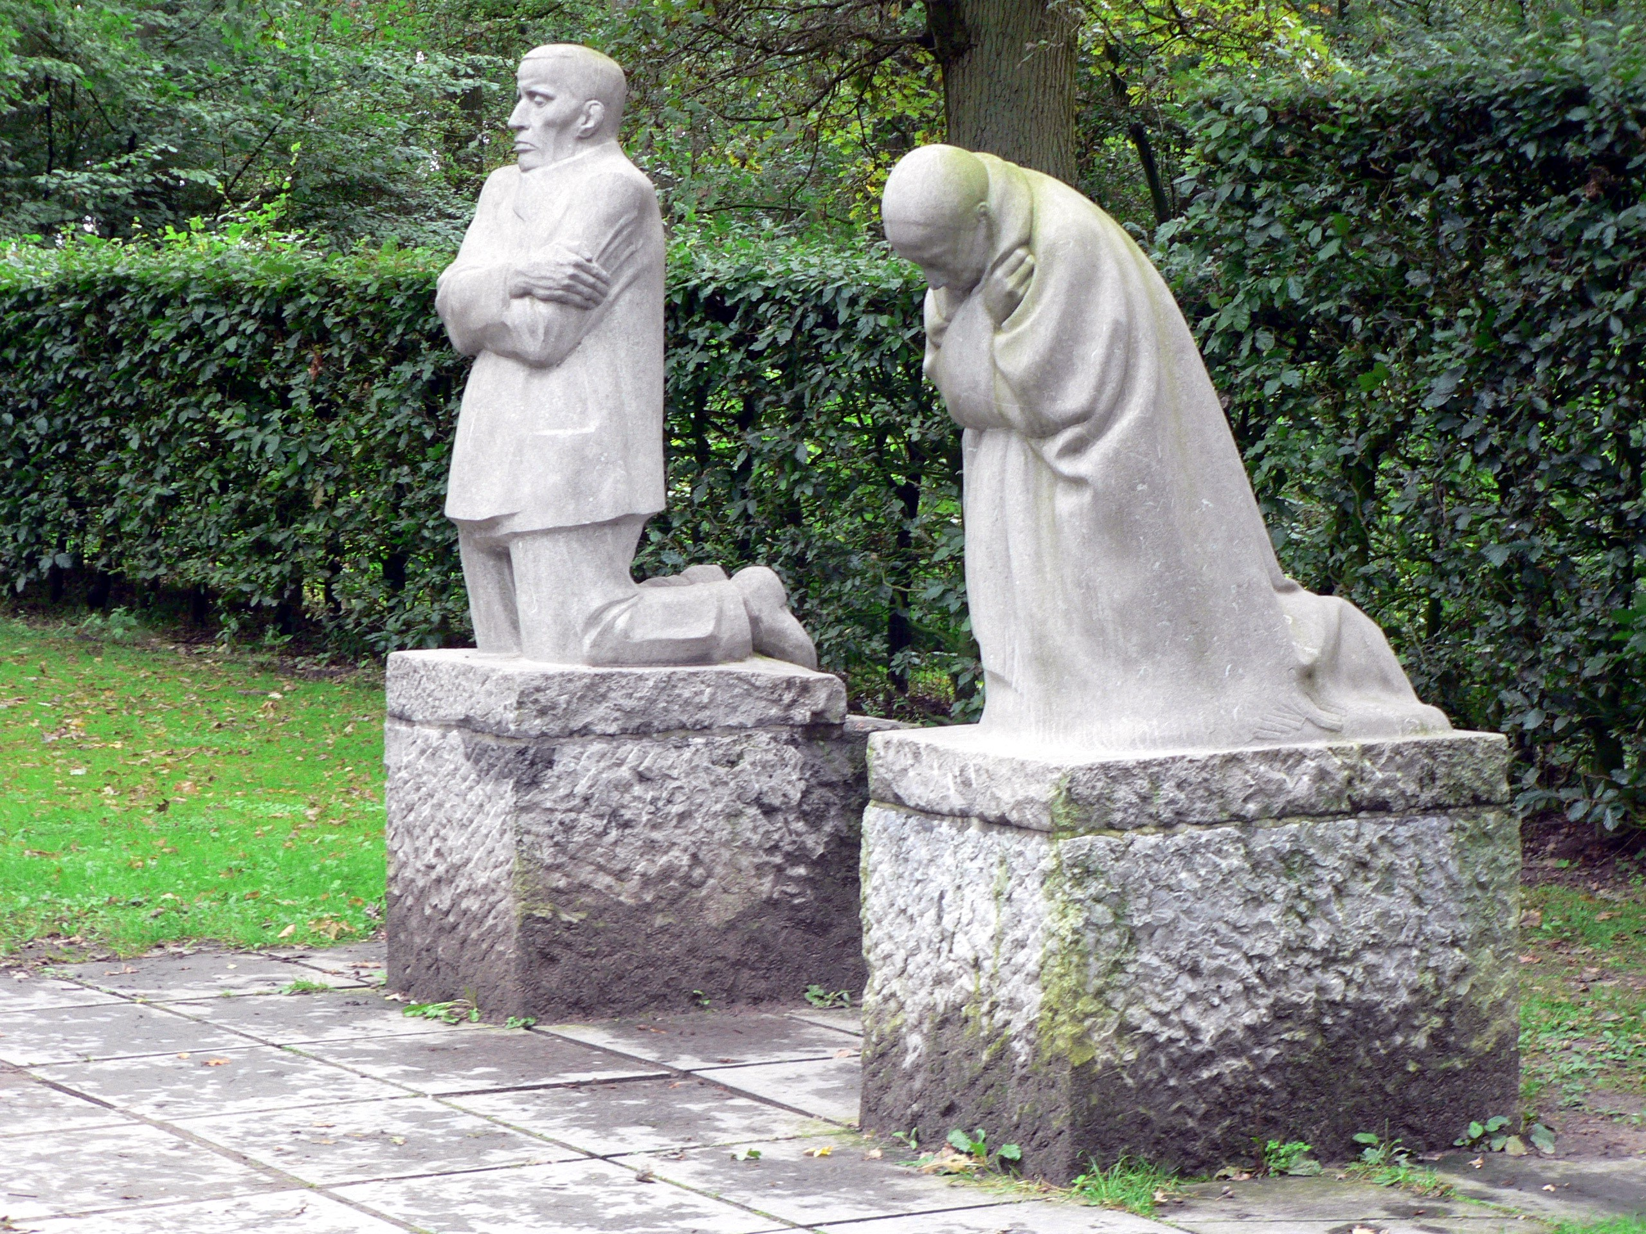
What if you are using images? These can be placed in the text at quarter-page size with appropriate captions and a citation to the source. But you might want to put them in an appendix. This will allow you to include them at a larger size and all in one place. (Just for reference I include an example here in the text and one in an appendix. You would want to do one or the other but not both). In any case, you can refer to your images by figure number. So, you could write: After years of reflection and experimentation, Käthe Kollwitz created The Grieving Parents (Die trauernden Eltern), stone sculptures of a mother and a father kneeling in remorse and overlooking the German military cemetery in Belgium where her son was buried (Figure 1).
Figure 1. Käthe Kollwitz, The Grieving Parents, Wikimedia Commons, commons.wikimedia.org (accessed November 12, 2019)
Let me share a few other details to get you started. Notes should be numbered sequentially through the paper. Do not reuse numbers (as Wikipedia does). The reference should be placed at the end of the sentence and always after any marks of punctuation. The first reference to a book or article should provide a full reference. After this, it is enough to use the author’s name and a short title. The note should specify the page in question, unless you are making general reference to a work. You can indicate a page and the following page by adding “f” to the page number (eg, 53f). You can indicate a page and the following pages by adding “ff” to the page number (eg, 53ff), though it is best to indicate the complete range of pages if you can. The bibliographical information should be taken from the title page of the work in question. So, if no author is listed, you can simply write “Anonymous” in place of author. You can indicate that no publisher information is provided (“n.p.”) or that date of publication is missing (“n.d.”). Here’s an example from our text. Here’s an example for a later reference to the same text (but a different page). Some other examples? A sample footnote to a journal article. A document in a reader. A newspaper article. And a film.
What else can I say about the mundane requirements of formatting? A few further mechanical points are worth pointing out. You must include page numbers for every page after the first page (in the upper right corner or centered at the bottom). The author’s last name may be added before the page number in the upper right-hand corner. You may use either italics or underlining in your paper, but not both. Underline or italicize the titles of books. Put the titles of articles in quotation marks. Learn the distinction between the hyphen (“-“ for hyphenating compound words) and the dash (“—”, for setting off a parenthetical remark. If you are turning in a hard copy of your paper, feel free to print your papers double sided and be sure to staple the pages together.
As for the writing, I might just set out a few guidelines for history papers. Avoid the “I” in history papers unless you know what you are doing. Do not use contractions in formal papers; thus, you should never write “it’s” (the contraction of “it is”) in a college paper. Use the full name of persons on your first reference. Include, in parentheses, the date of primary sources and films the first time that you refer to them.
I have much more to say about the minutiae of formatting and strategies for good writing. I have lectured elsewhere on: “The Semicolon: Poster Child for Abused Punctuation Marks”; “Sticklers Unite!—A Hyphen is Not a Dash”; “Behind Every Good Paper is a Good Outline”; “How to Use the ‘I’ in History Without Getting Personal”; “It Would Be Much Easier To Write This Paper If I Knew What I Wanted To Say.” And much, much more.

Figure 1. Figure 1. Käthe Kollwitz, The Grieving Parents, Wikimedia Commons, commons.wikimedia.org (accessed November 12, 2019).

Bibliography

Primary Sources
Beveridge, Sir William. “New Britain.” Address to Oxford University. December 6, 1942. In University of Chicago Readings in Western Civilization vol. 9, edited by John W. Boyer and Jan E. Goldstein, 503-515. University of Chicago Press, 1987.
“Urgent Tasks.” Times of London. June 30, 1947.
Reed, Carol, dir. The Third Man. United Kingdom, 1949. Criterion Collection, 2007. DVD.

Secondary Sources
Kershaw, Ian. To Hell and Back: Europe 1914–1949. Penguin, 2015.
Leffler, Melvin. “The Cold War: What Do ‘We Now Know’?” American Historical Review 104 (1999): 501-524.

Al Franken, Lies (and the Lying Liars Who Tell Them) (Dutton, 2003), 12-16, explains the ways that popular authors use footnotes to give their work false authority.
Mary Lynn Rampolla, A Pocket Guide to Writing in History, 5th ed. (Bedford/St. Martin’s, 2007), 104.
“General Model for Citing Web Sources in Chicago Style,” Purdue Online Writing Lab, Purdue University, accessed November 12, 2019, owl.purdue.edu. “Chicago-Style Citation Quick Guide,” Chicago Manual of Style (2017) chicagomanualofstyle.org.
Ian Kershaw, To Hell and Back: Europe 1914–1949 (Penguin 2015), 523.
Kershaw, To Hell, 44f.
Melvin Leffler, “The Cold War: What Do ‘We Now Know’?” American Historical Review 104 (1999): 501-524.
Sir William Beveridge, “New Britain,” address to Oxford University (December 6, 1942), in University of Chicago Readings in Western Civilization, vol. 9, ed. John W. Boyer and Jan Goldstein (University of Chicago Press, 1987), 503-515.
“Urgent Tasks,” Times of London, June 30, 1947, 5.
The Third Man, dir. by Carol Reed (UK, 1949; Criterion Collection, 2007, DVD).

